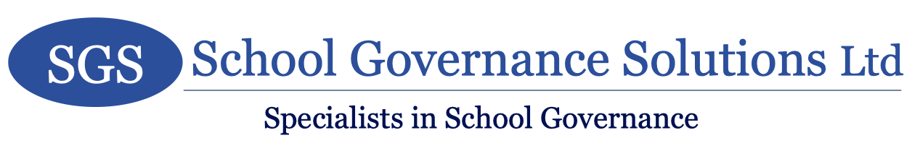
Privacy Notice 2021/2022

To enable us to discharge the services agreed within the Service Level Agreement as Clerk to the Governors with the school, comply with related legal and regulatory obligations and for other related purposes including updating and enhancing client records and analysis for management purposes, as a data controller, we may obtain, use, process and disclose personal data about you as described in our privacy notice. We confirm when processing data on your behalf that we will comply with the provisions of all relevant data protection legislation and regulation.

You are also an independent controller, responsible for complying with data protection legislation and regulation in respect of the personal data you process and, accordingly where you disclose personal data to us, you confirm that such disclosure is fair and lawful and otherwise does not contravene relevant requirements.

Privacy Notice

Privacy notice for School Governance Solutions Ltd
School Governance Solutions Ltd takes the protection of your privacy very seriously. We will only use your personal information to deliver the products and services you have requested from us (via the Service Level Agreement as Clerk to the Governors with the school) and to meet our legal responsibilities.
How do we collect information from you?
We obtain information about you when you are appointed as a governor.
What type of information do we collect from you?
The personal information we collect might include your name, address, telephone number and email address.
How is your information used?
In general terms and as part of providing our agreed services we may use your information to:
• contact you by post, email or telephone
• verify your identity where this is required
• understand your needs and how they may be met
• maintain our records in accordance with applicable legal and regulatory obligations
We are required by legislation, other regulatory requirements and our insurers to retain your data where we have ceased to act for you. To ensure compliance with all such requirements it is the policy of the firm to retain all data for a period of seven years from the end of the period concerned.
Who has access to your information?
We will not sell or rent your information to third parties.
We will not share your information with third parties for marketing purposes.
Any staff with access to your information have a duty of confidentiality under the ethical standards that this firm is required to follow.

Third-Party Service Providers
We may pass your information to a third-party service provider (Local Authority). However, we disclose only the personal information that is necessary to deliver the service. Please be assured that we will not release your information to other third parties unless you have requested that we do so.

How you can access and update your information
Keeping your information up to date and accurate is important to us. We commit to regularly review and correct, where necessary, the information that we hold about you. If any of your information changes, please email or write to us, or call us using the ‘Contact information’ noted below.
You have the right to ask for a copy of the information that School Governance Solutions Ltd. holds about you.

Security precautions in place to protect the loss, misuse or alteration of your information
Whilst we strive to protect your personal information, we cannot guarantee the security of any information you transmit to us, and you do so at your own risk.
Once we receive your information, we make our best effort to ensure its security on our systems. Where we have given, or where you have chosen, a password which enables you to access information, you are responsible for keeping this password confidential. We ask you not to share your password with anyone.
Your data will usually be processed in our offices in the UK. However, to allow us to operate efficient digital processes, we sometimes need to store information in servers located outside the UK, but within the European Economic Area (EEA). Our data is stored on Microsoft servers utilising Microsoft 365 technologies. All electronic communication sent by us is secured with a minimum or TLS1.2. We take the security of your data seriously and so all our systems have appropriate security in place that complies with all applicable legislative and regulatory requirements.
Your choices
We may occasionally contact you by post, email and/or telephone with details of any changes in legal and regulatory requirements or other developments that may be relevant to your affairs and, where applicable, how we may assist you further.
Your rights
Access to your information: You have the right to request a copy of the personal information about you that we hold.
Correcting your information: We want to make sure that your personal information is accurate, complete and up to date and you may ask us to correct any personal information about you that you believe does not meet these standards.
Deletion of your information: You have the right to ask us to delete personal information about you where:
• you consider that we no longer require the information for the purposes for which it was obtained
• you have validly objected to our use of your personal information - see ‘Objecting to how we may use your information’ below
• our use of your personal information is contrary to law or our other legal obligations
• we are using your information with your consent and you have withdrawn your consent - see ‘withdrawing consent to use your information’ below.
Retention Periods: Except as otherwise permitted or required by applicable law or regulation, SGS only retains personal data for as long as necessary to fulfil the purposes they collected it for, as required to satisfy any legal, accounting or reporting obligations or as necessary to resolve disputes.
Restricting how we may use your information: In some cases, you may ask us to restrict how we use your personal information. This right might apply, for example, where we are checking the accuracy of personal information about you that we hold or assessing the validity of any objection you have made to our use of your information. The right might also apply where there is no longer a basis for using your personal information, but you do not want us to delete the data. Where this right is validly exercised, we may only use the relevant personal information with your consent, for legal claims or where there are other public interest grounds to do so.
Objecting to how we may use your information: Where we use your personal information to perform tasks carried out in the public interest then, if you ask us to, we will stop using that personal information unless there are overriding legitimate grounds to continue.
Please contact us in any of the ways set out in ‘Contact information’ below if you wish to exercise any of these rights.
Changes to our privacy notice
We keep this privacy notice under regular review. Paper copies of the privacy notice may also be obtained from our office.
This privacy notice was last updated on 18 July 2021.

Contact information
School Governance Solutions Ltd
8 Acland Road
Bridgend
CF31 1TF
simonedelaney@schoolgovernancesolutions.com

Complaints
We seek to resolve directly all complaints about how we handle your personal information, but you also have the right to lodge a complaint with the Information Commissioner’s Office at
Information Commissioner's Office
Wycliffe House
Water Lane
Wilmslow
Cheshire
SK9 5AF
Telephone - 0303 123 1113 (local rate) or 01625 545 745
Website: https://ico.org.uk/concerns

